**PROJECT DESIGN PHASE-2**

**CUSTOMER JOURNEY**

|  |  |
| --- | --- |
| **TEAM ID** | PNT2022TMIDO7514 |
| **DATE** | 01 NOVEMBER 2022 |
| **PROJECT NAME** | IOT BASED SMART CROP ROTECTION SYSTEM FOR AGRICULTURE |
| **MARKS** | 4 MARKS |

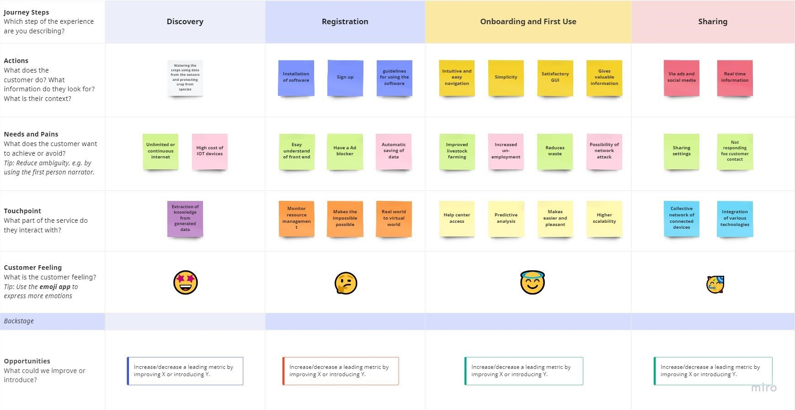 CUSTOMER JOURNEY MAP: